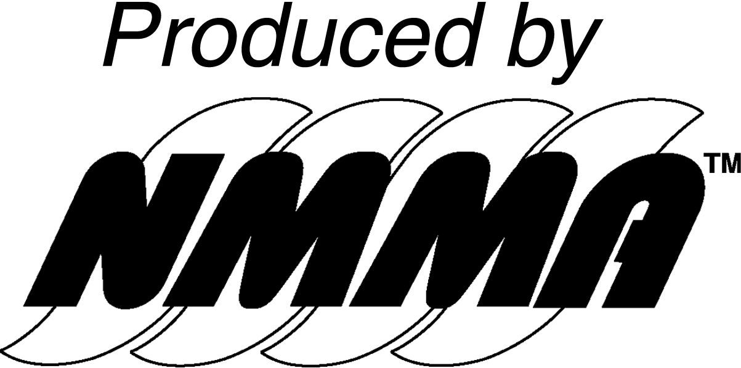

SERVICE CONTRACTORS

PUBLIC RELATIONS
Wax Marketing, Inc.
Ms. Bonnie Harris
333 Grand Ave., Ste 209
St. Paul, MN 55012
Telephone (612) 801-0192

bonnie@waxmarketing.com

OFFICIAL DECORATOR
Brede Exposition Services
Mr. Scott Anderson, Account Executive
2211 Broadway St. NE
Minneapolis, MN 55413
Telephone (612) 378-6524
Fax (612) 331-8380
sanderson@brede.com
www.brede.com

DISPLAY INSTALLATION
Brede Exposition Services
2211 Broadway St. NE
Minneapolis, MN 55413
Telephone (612) 378-6524
Fax (612) 331-8380

FURNITURE, DECORATIONS
Brede Exposition Services
2211 Broadway St. NE
Minneapolis, MN 55413
Telephone (612) 378-6524
Fax (612) 331-8380

FLOOR COVERING
Brede Exposition Services
2211 Broadway St. NE
Minneapolis, MN 55413
Telephone (612) 378-6524
Fax (612) 331-8380

SECURITY
Minneapolis Convention Center
1301 Second Ave South
Minneapolis, MN 55403
Telephone (612) 335-6040

ELECTRICAL, TELEPHONE, CLEAINING, WATER AND DRAIN SERVICE
Minneapolis Convention Center
1302 Second Avenue South
Minneapolis, MN 55403
Telephone (612) 335-6550

HIGH SPEED INTERNET ACCESS
Priority Network, Inc
1856 Pama Lane
Building B1
Las Vegas NV 89119
Telephone (612) 335-6165
Toll Free (800) 214-7780
Fax (702) 967-9310

CATERING
Kelber Catering
Ms. Heidi Hudson, Catering Sales Coordinator
1301 Second Avenue South
Minneapolis MN 55403
Telephone (612) 335-6082
heidih@kelber.com

