A Picture Book concerning the

NMMA 2005 Summer Test Program:

Carbon Canisters for Marine Diurnal Control

Prepared by
Harold Haskew & Associates, Inc.
Milford MI 48381
hhanda.com

June 29, 2005
NMMA Boat Test Summary
June 27, 2005

14 Boats In-Service (Sorted by Canister Size)

- Four Winns 17’ Open Bow 24 gallon Delphi 1.0L
- Four Winns 18’ Open Bow 32 gallon Delphi 1.0L
- Crestliner 17’ Open Boat 24 gallon Delphi 1.0L
- Crestliner 18’ Open Boat 31 gallon Delphi 1.0L
- Crestliner 23’ Pontoon 25 gallon Delphi 1.0L
- Crestliner 23’ Pontoon 25 gallon Delphi 1.0L
- Four Winns 19’ Open Bow 50 gallon Delphi 1.5L
- Four Winns 21’ Open Bow 50 gallon Delphi 1.5L
- Four Winns 27’ Cruiser 85 gallon Delphi 2.5L
- Century 26’ Sportfisherman 150 gallon Delphi 4.0L
- Century 26’ Off Shore 150 gallon Delphi 4.0L
- Grady White 23’ Off Shore 150 gallon Delphi 4.0L
- Grady White 30’ Off Shore (2) 150 gallon (2) Delphi 4.0L
- Century 29’ Sportfisherman 300 gallon Delphi (2) 3.5 L
(in series)

Note: The following pages have photos of the actual canister installations. The overall boat photos are catalog shots.

NMMA Summer Test Program – 2005

Four Winns

Four Winns 170 HORIZON – Open bow model, in water at Test Center (GFNMC003D304)
Fuel tank(s) capacity: Single plastic belly tank, 24 gallon
Canister vendor: DELPHI Capacity: 1.0 L
In-service date: May 24th, 2005

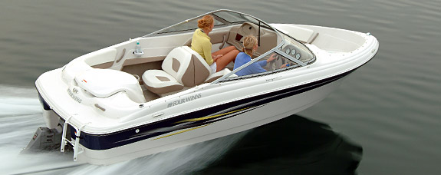

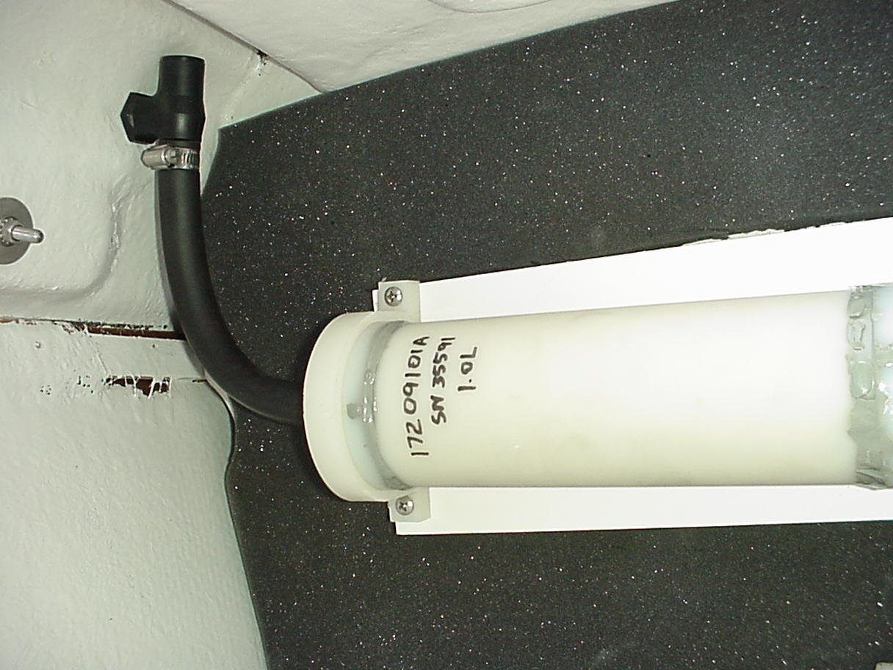
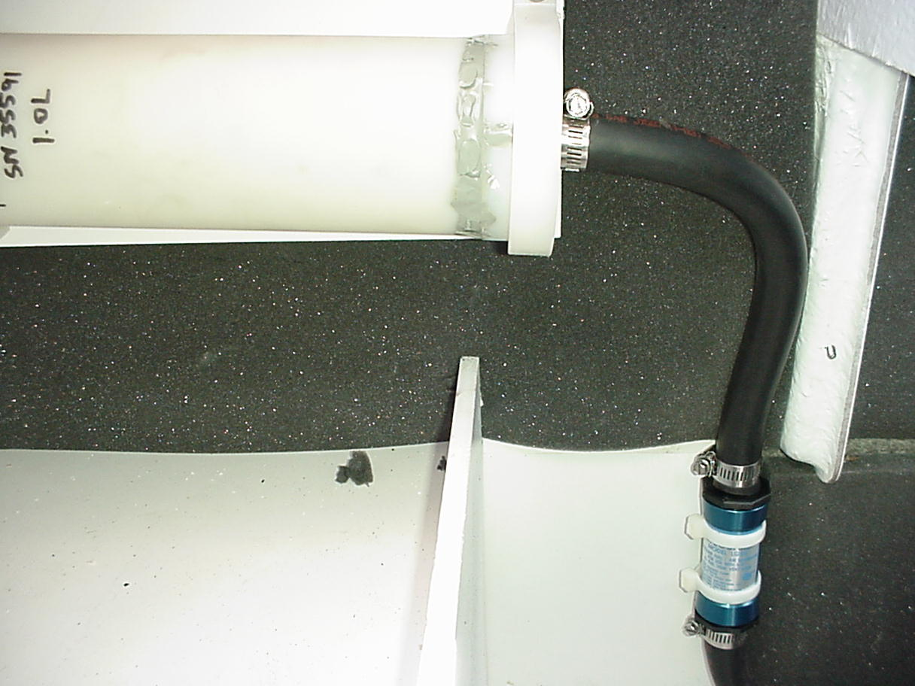
Engine compartment - Aft side of deck – Bulkhead mount

Four Winns 180 HORIZON – Open bow model, in water at Test Center (GFNMVVECB3)
Fuel tank(s) capacity: Single plastic belly tank, 32 gallon
Canister vendor: DELPHI Capacity: 1.0 L
In-service date: May 24th, 2005

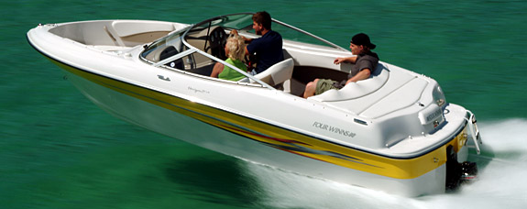

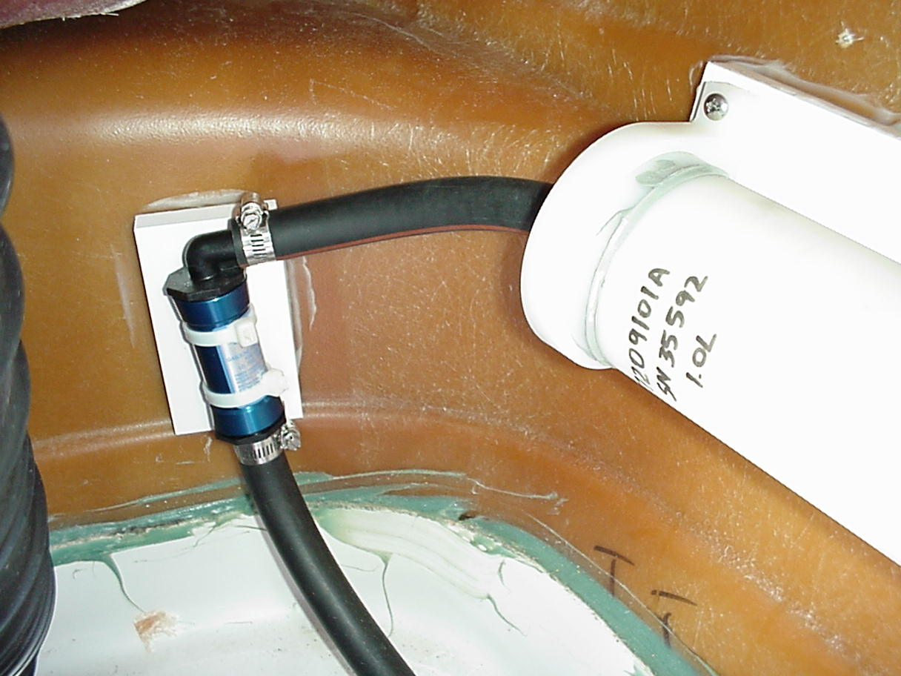
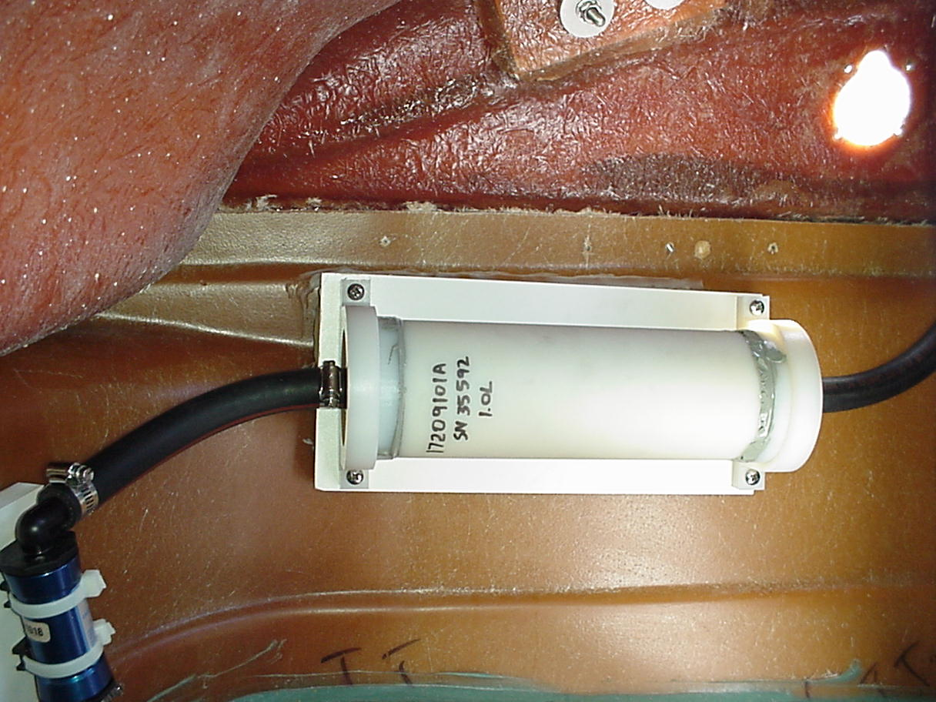
Engine compartment - Port hull side mount

Four Winns 194 FUNSHIP – Deck boat model, in water at Test Center (GFNMCK001K204)
Fuel tank(s) capacity: Single plastic belly tank, 50 gallon
Canister vendor: DELPHI Capacity: 1.5 L
In-service date: May 24th, 2005

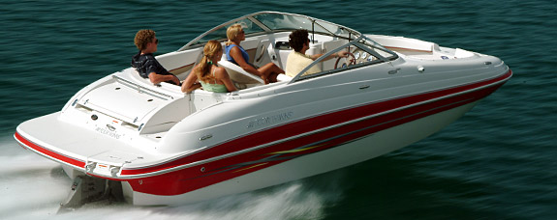

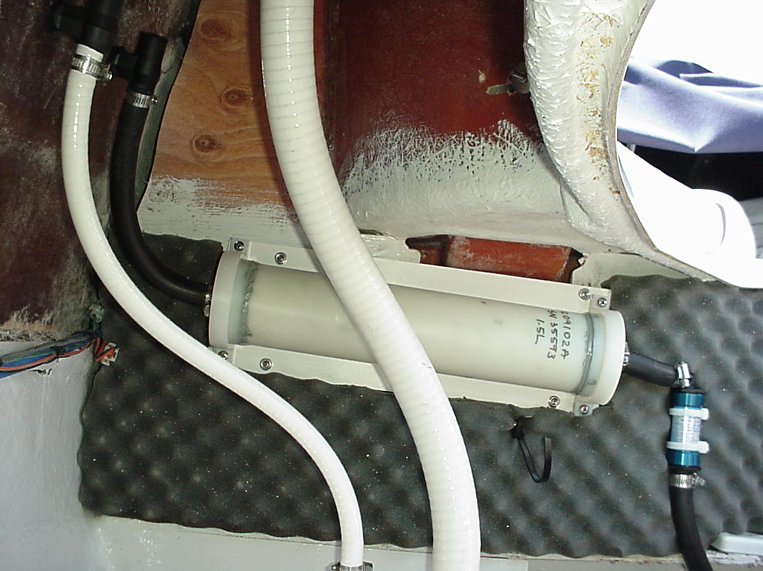
Engine compartment - Aft side of deck – Bulkhead mount

Four Winns 210 HORIZON – Open bow model, trailered test boat (GFNMCK001K204)
Fuel tank(s) capacity: Single plastic belly tank, 50 gallon
Canister vendor: DELPHI Capacity: 1.5 L
In-service date: May 24th, 2005

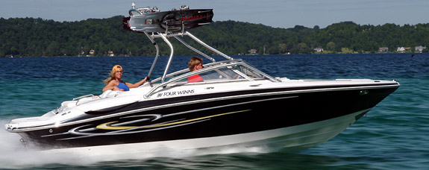

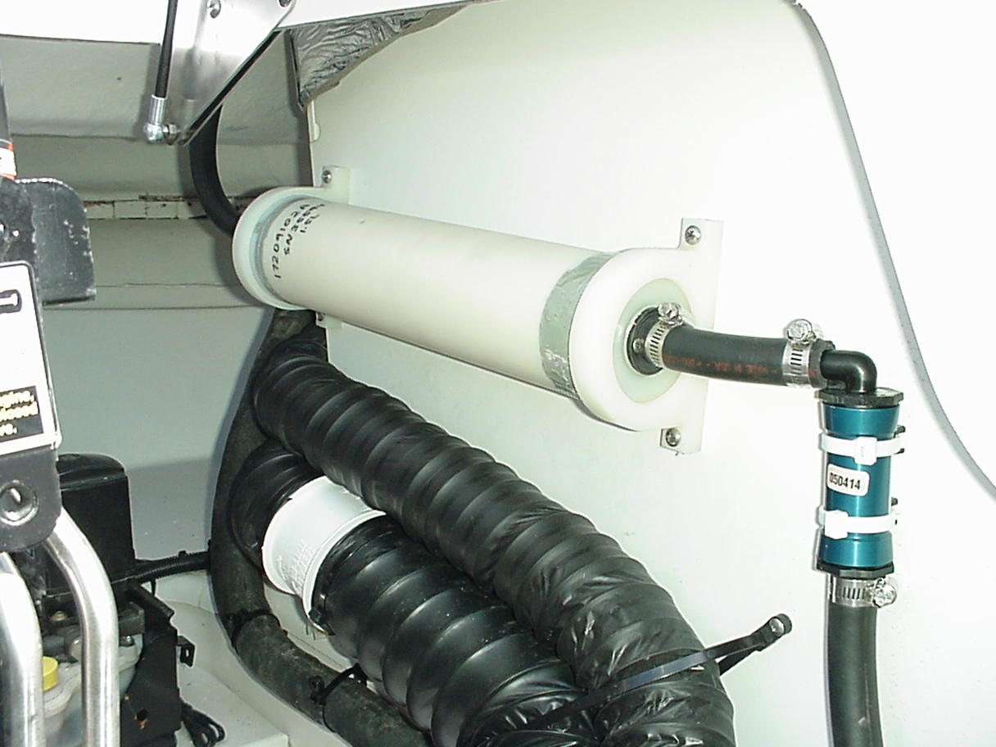
Engine compartment, bulkhead mount
Four Winns 278 VistaCruiser Torch Lake Test (GFNMCY001G405)
Fuel tank(s) capacity: Single plastic belly tank, 85 gallon
Canister vendor: DELPHI Capacity: 2.5 L
In-service date: May 24th, 2005

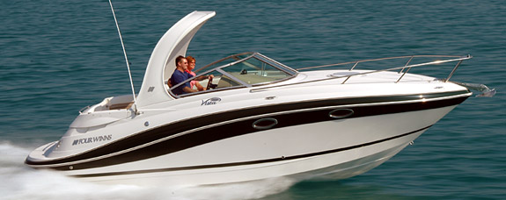

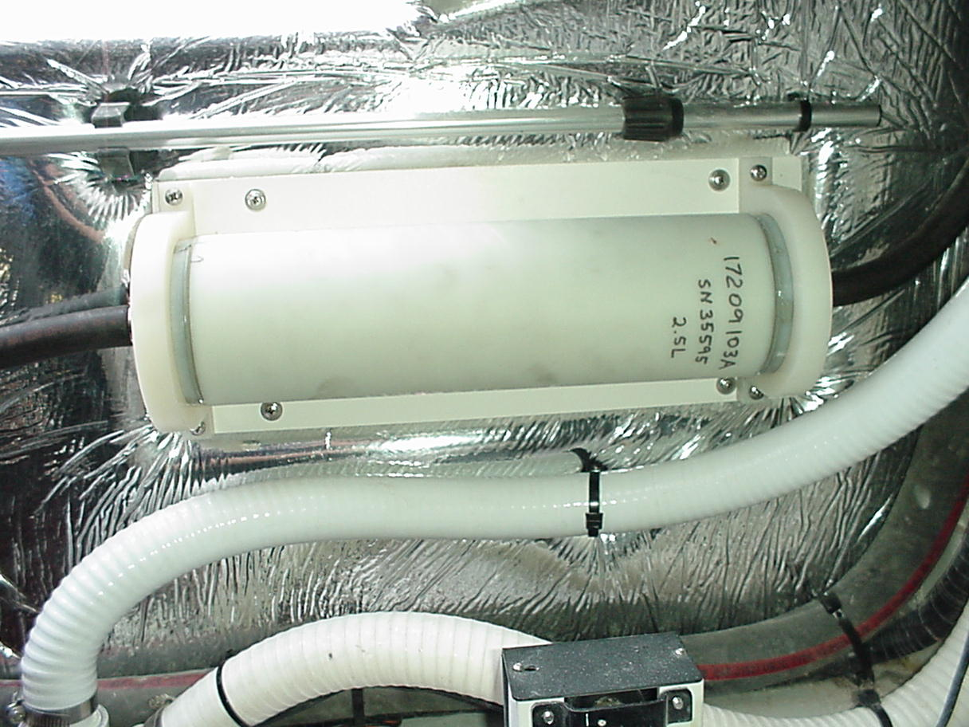
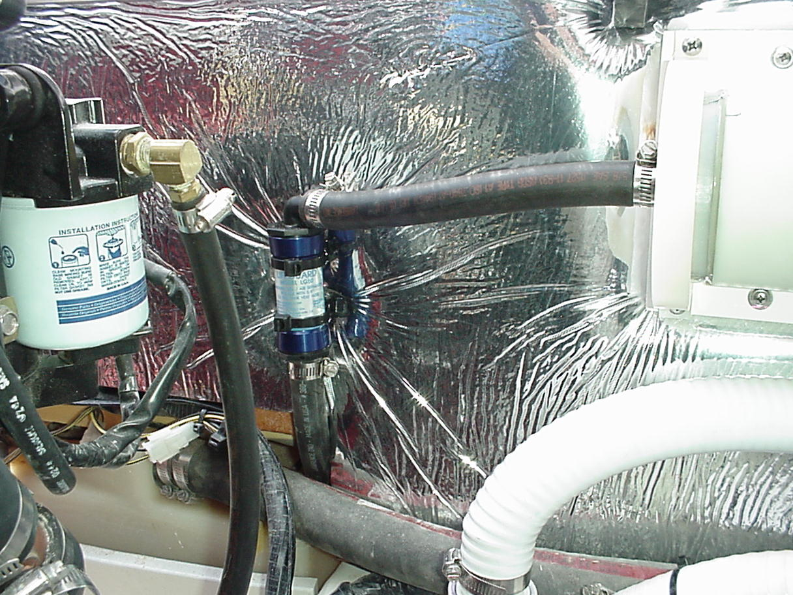
Engine compartment, bulkhead mount

Craig Scholten
Four Winns
925 Frisby
Cadillac, MI 49601
cscholt@fourwinns.com

Century

2900 Center Console – Fuel capacity, single 300 gallon tank – Panama City location

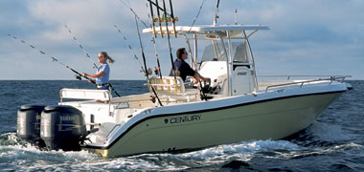

2600WA – Fuel capacity, single 150 gallon tank – Cypress, CA location

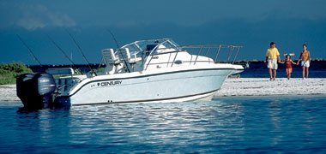

Todd Williams
Engineering Manager
C & C Manufacturing, Inc.
6725 Bayline Drive
Panama City, FL 32404
850 767 3144 Todd_Williams@Yamaha-motor.com

WA2600 Century (26 ft. 6 inches. LOA) (CEB026WWB404) West Coast Boat
Fuel Capacity: 150 gallons. Aluminum Fuel Tank Delphi 4.0L Canister
Type of use: Off Shore fishing 100-200 hours/year
Twin Port and Starboard Fill necks
Single Vent (Port Side below deck cap)
Power: Twin F150 TLRC Outboards serial F150txrc 63PX 1006217 / LF150txrc 64P 1000936

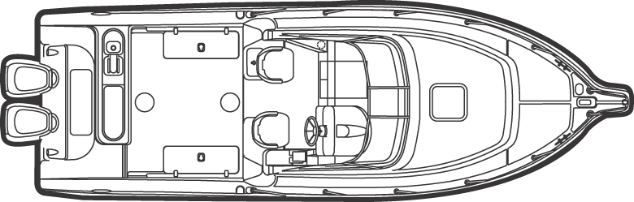

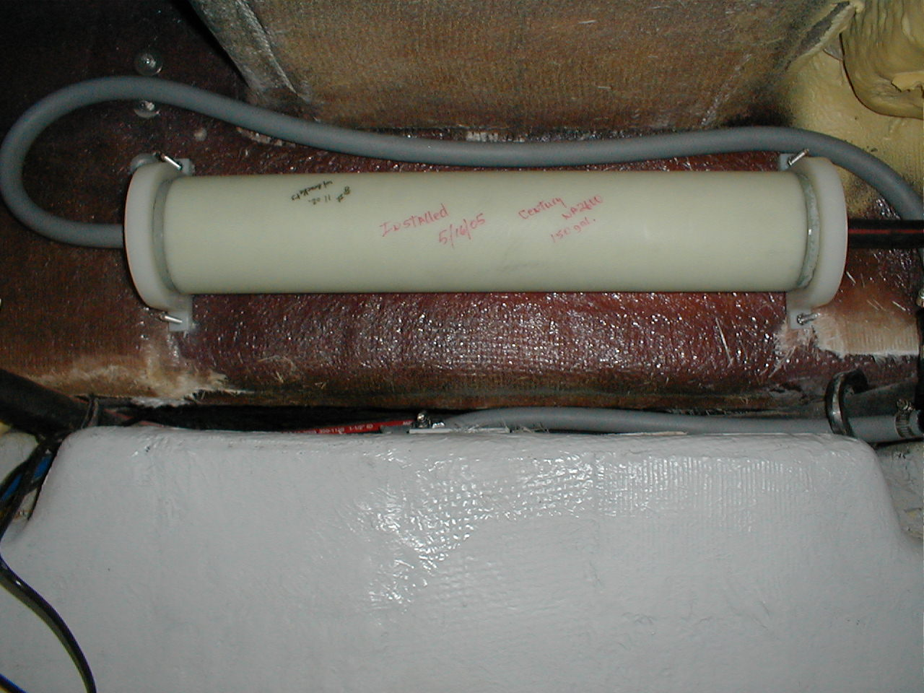
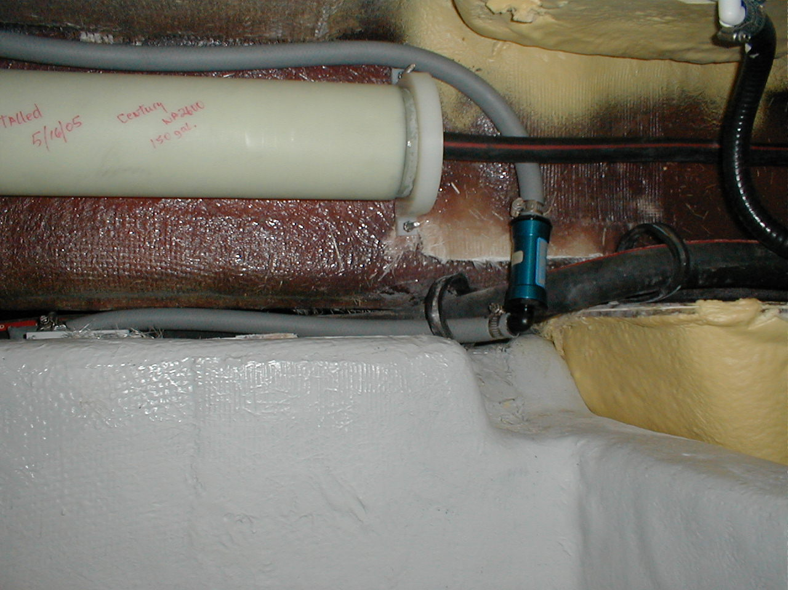

Installed Delphi 4.0 liter prototype (26 inches L x 6” dia. at a weight of 9#) directly above tank and below cockpit sole using brackets provided by vendor. Secured with (4) ¼ x 2” SS pan head bolts with nyloc nuts. Installed Racor LG50 separator/fuel stop prior to the starboard side entrance to canister.

Canister is approximately 18 inches below current vent outlet on hull.

Dan Ostrosky
Manager, Government Relations
Yamaha Motor Corporation USA
6555 Kattella Ave.
Cypress, CA 90630-5101 Dan_ostrosky@yamaha-motor.com
Grady White

232 Gulfstream: 23’ walkaround cabin offshore sportfishing boat (NTLCZ201E506)
Single 150 gallon tank, Delphi 4.0L Canister
Estimated in-service date 6/2/05

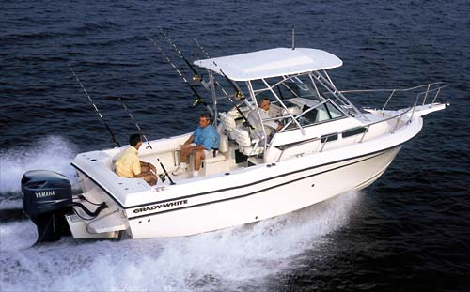

Grady White

306 Bimini: 30’ center console offshore sportfishing boat (NTLCC201D506)
(2) tanks- 156 gallon main & 150 gallon aux (2) Delphi 4.0L Canisters
Estimated in-service date 6/2/05

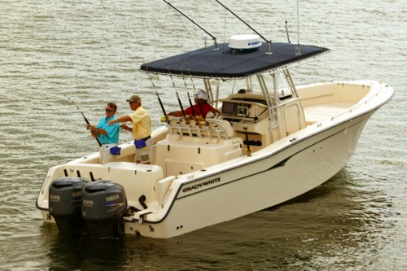

Joe Hunter
Grady White Boats
5121 Greenville Blvd. NE
Greenville, NC 27834 jhunter@gradywhite.com

Crestliner

1750 Fish Hawk Contender – (CRC22123C506)
24 Gal Tank – Delphi 1.0L canister – In-service 6/17/05

1850 Fish Hawk Contender - (CRC22367D506)
31 gallon Tank – Delphi 1.0L canister – In-service 6/14/05

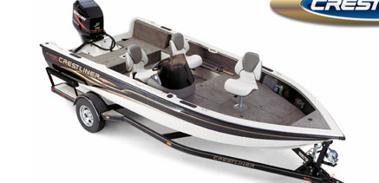

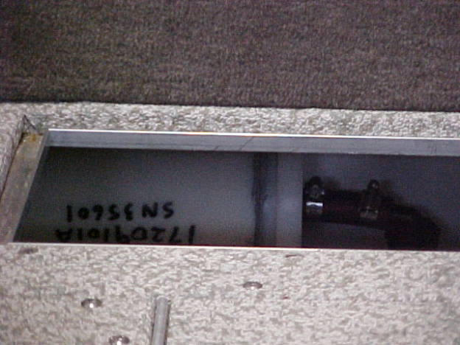
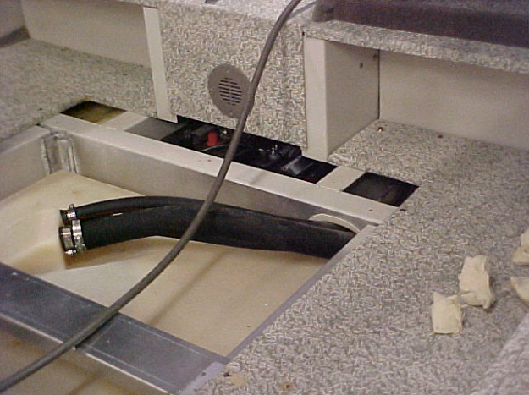

Note: The space and access available for the canister mounting and vent modifications was very limited for these models. Future designs will require time, new design features, and tooling changes to accommodate this rule if it evolves.
2285 LSI Pontoon Boat and the 2285 LSI Angler Edition Pontoon Boat
In-Service Dates 6/16/05

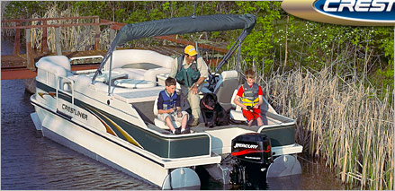

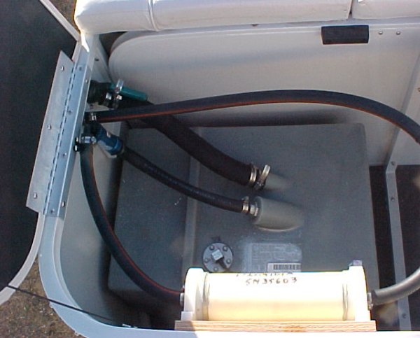
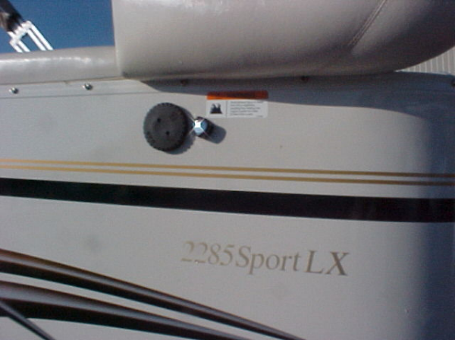

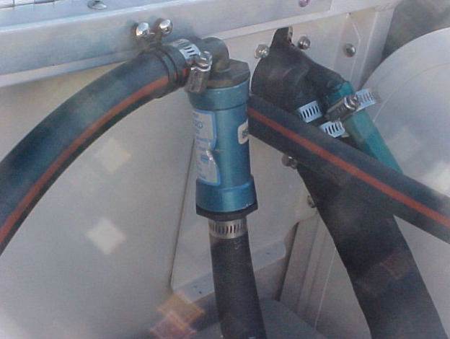
The fuel fill fitting available for these installations was the “Combo” vent. The vent was closed with the green cap shown, and the gas cap internal vent was sealed with RTV sealant.

Tim Loberg
Compliance Specialist
Crestliner Boats
609 13th Ave Ne
Little Falls, MN 56345-2221
(320) 632-6686 tloberg@crestliner.com

